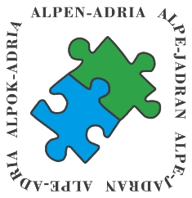
15. Triathlon-Cup 2023

1. Preamble

The Alps Adriatic Triathlon Cup ("AATC") was signed on 28 th May 2008 by Dott. Enrico Tion (Friuli-Venezia-Giulia), Miro Kregar (Slovenia) and Ing. Hannes Buerger (Carinthia) in Udine. Triathletes of all ages from the Alps Adriatic-space should have the opportunity to log in peaceful sporting competition to be measured and the relationships between them to improve.

2. Dates and Locations 2023:

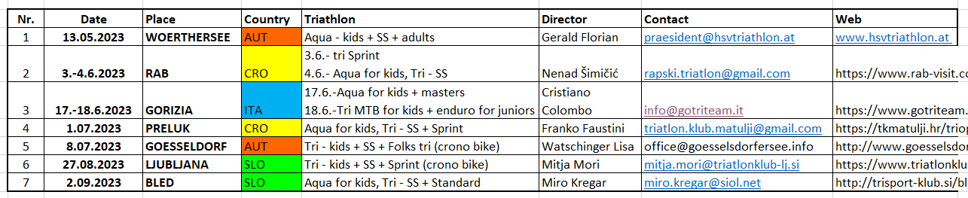

3. Points:

In each age group the points will be following awarded:

1. Place: 100 | 8. Place: 32 | 15. Place: 16 | 22. Place: 9 | 29. Place: 2
2. Place: 80 | 9. Place: 29 | 16. Place: 15 | 23. Place: 8 | 30. Place: 1
3. Place: 60 | 10. Place: 26 | 17. Place: 14 | 24. Place: 7 | 31. Place: 1
4. Place: 50 | 11. Place: 24 | 18. Place: 13 | 25. Place: 6 | and on
5. Place: 45 | 12. Place: 22 | 19. Place: 12 | 26. Place: 5
6. Place: 40 | 13. Place: 20 | 20. Place: 11 | 27. Place: 4
7. Place: 36 | 14. Place: 18 | 21. Place: 10 | 28. Place: 3

4. Classification:

It will be advertised 13 senior-classes (Juniors – M/W 75+) and 6 kids-classes (kids E – Youth). All classes considers male and female. For scoring in the Cup, the participation in THREE races is required. The best FIVE results will be considered.

OVERALL MEN + WOMEN (1-3 place)
Senior-classes 2023:

Juniors | 2005 - 2004
M/W U 23 | 2003 - 2000
M/W 24 - 29 | 1999 - 1994
M/W 30 - 34 | 1993 - 1989
M/W 35 - 39 | 1988 - 1984
M/W 40 - 44 | 1983 - 1979
M/W 45 - 49 | 1978 - 1974
M/W 50 - 54 | 1973 - 1969
M/W 55 - 59 | 1968 - 1964
M/W 60 - 64 | 1963 - 1959
M/W 65 - 69 | 1958 - 1954
M/W 70 - 74 | 1953 - 1949
W/W 75 + | 1946 and older

Kids-classes 2023:
kids E | 2016 and younger
kids D | 2015 - 2014
kids C | 2013 - 2012
kids B | 2011 - 2010
kids A | 2009 - 2008
Youth | 2007 - 2006

5. Prices

Valuable sports prizes for overall men and overall women rank 1-3 (6 prizes). Trophies for place 1 to 3 in all kids and senior classes (26 seniors and 12 kids classes – together 38). Award party for all finishers at the ceremony.
5. Award Ceremony:

This will be taken place in Slovenia, close to Ljubljana at Saturday, 7.10.2023 at 2 p.m.
Place – BOBI BAR - POSLOVNA CONA KOMENDA, SLOVENIA
https://goo.gl/maps/FMDZVv7oVqv6LSzF8

The CEO-members A-A-T-C 2023:
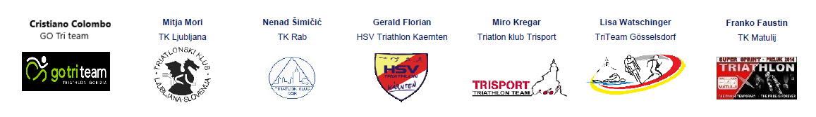

Organizator:
TK TRISPORT KAMNIK
Zg. Stranje 47
1242 Stahovica
SLOVENIA

